***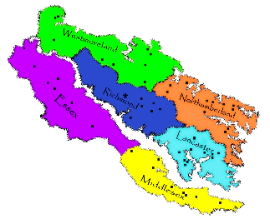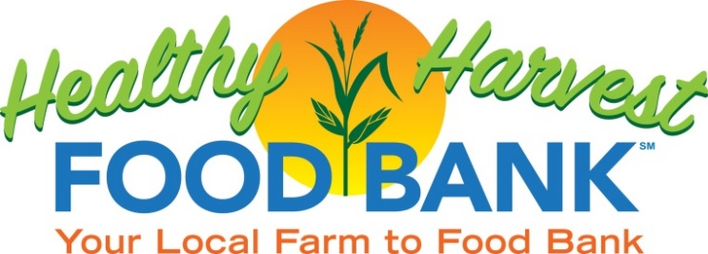

**Westmoreland County**  
Food Bank Member Pantries: 9  
Back Pack Program: 135 children   
 served weekly  
Meals Distributed: 207,208

**$50.00**

**Donation   
=   
400 Meals**

**$100.00**

**Donation   
=   
100 Meals**

**$25.00**

**POUNDS OF FRESH PRODUCE FROM LOCAL FARMERS**

**494,125**

**FOOD BANK SERVICE AREA QUICK FACTS**

**Turning Hunger into Hope**

**Donation   
=   
200 Meals**

**(340,686 meals sent to other Virginia Food Banks!)**

**Essex County**  
Food Bank Member Pantries: 2 **(NEW)** Back Pack Program: 145 children served weekly   
Meals Distributed: 127,737

**Middlesex County**Food Bank Member Pantries: 6 Plus  
 1 Senior Program   
Back Pack Program: 180 children   
 served weekly  
Meals Distributed: 321,246

**Northumberland County**  
Food Bank Member Pantries: 5  
Back Pack Program: 57 children  
 served weekly   
Meals Distributed: 219,440

**PARTNER AGENCIES ACROSS SIX COUNTIES**  
Lancaster, Northumberland, Richmond, Essex, Middlesex, and Westmoreland, including Colonial Beach

**Lancaster County**Food Bank Member Pantries: 7 Plus  
 2 Senior Programs  
Back Pack Program: 120 children   
 served weekly   
Meals Distributed: 320,357

**10,458**

**PEOPLE SERVED MONTHLY**

**Richmond County**  
Food Bank Member Pantries: 5  
Back Pack Program: 32 children   
 served weekly  
Meals Distributed: 138,649

**MEALS  
DISTRIBUTED**

**1,675,323**

**34**

55 Commerce Parkway  
P.O. Box 735  
Warsaw, VA 22572  
804-250-2277 ~ hhfb.org

**FY23 Food Bank Year End Statistics**

